0.00 | Start out on Portland Road
 | 0.07 | Turn left onto Leamington Avenue
 | 0.29 | Turn left onto Oak Tree Gardens
 | 0.38 | Turn right onto New Street Hill
A2212 | 0.57 | Turn right onto the A2212
 | 1.28 | At Grove Park Station, traffic signals continue forward
A205 | 2.36 | At traffic signals turn right onto the A205  S. Circular, Woolwich
 | 3.08 | At Clifton's Roundabout take the 2nd exit onto the A205  S. Circular, Woolwich, Docklands
 | 3.41 | At Yorkshire Grey Roundabout take the 2nd exit onto the A205  S. Circular, Woolwich, Bexleyheath, Docklands
 | 4.18 | At traffic signals turn right onto Rochester Way - A205
 | 4.24 | At Well Hall Roundabout take the 1st exit onto the A205  S. Circular, Woolwich Ferry
A207 | 5.02 | Show Map | Hotels | Restaurants  At traffic signals turn right onto the A207
 | 7.39 | At Welling, traffic signals continue forward  Dartford, Bexleyheath
 | 7.79 | Turn right onto Dwnham Court
A207 | 7.80 | Turn right onto the A207
 | 7.82 | Arrive on Park View Road
 |  | Section time 0:31, Total time 0:31
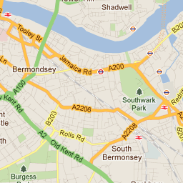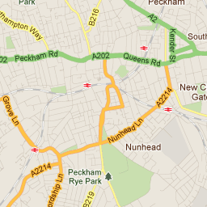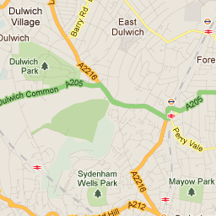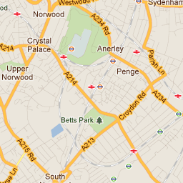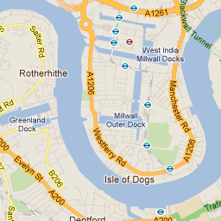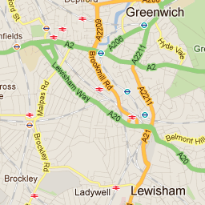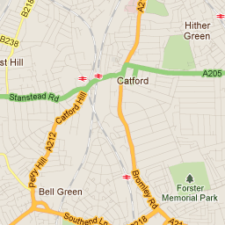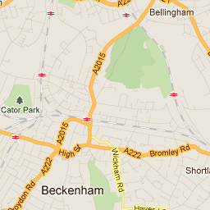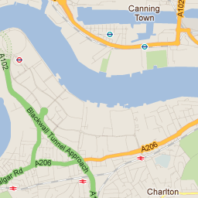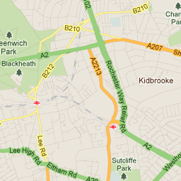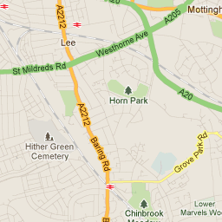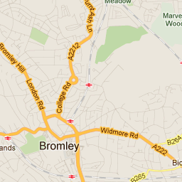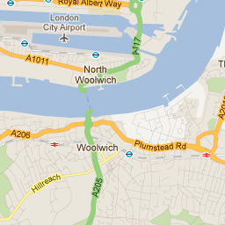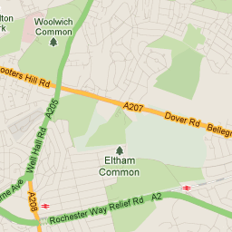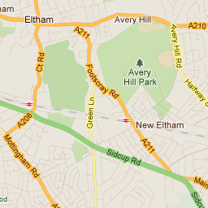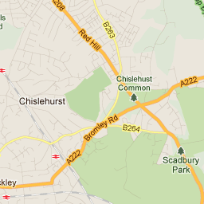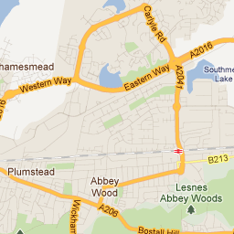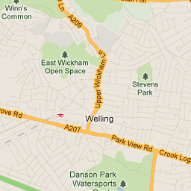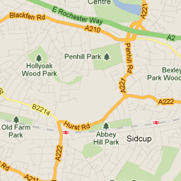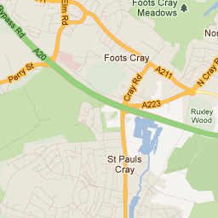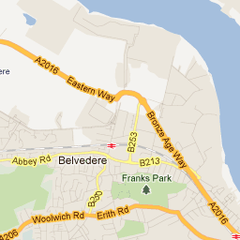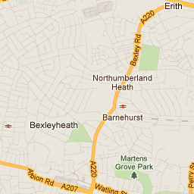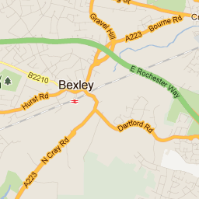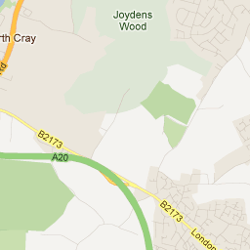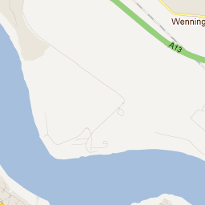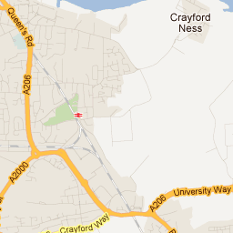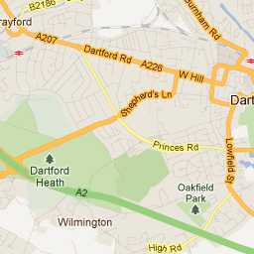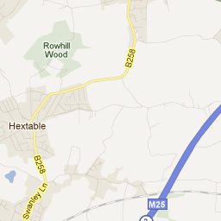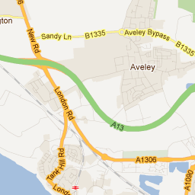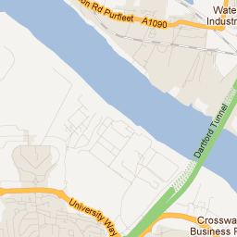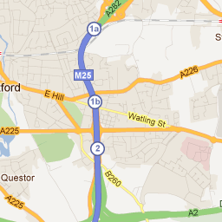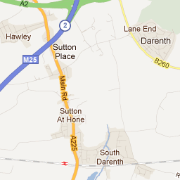
Map data ©2011 Tele Atlas - Terms of Use
2000 ft
1 km
Map
Satellite
Traffic

Parking

AA Hotels & B&Bs near your destination

View all Hotels & B&Bs in DA16 1SY

Bexleyheath Marriot...
Hotel
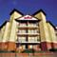

Holiday I

